COVER PAGE INFO HERE

**List of Figures**

Figure 1.1: Create the inv_tsp tablespace……………………………………………………....4

Figure 1.2: Create the dw_tsp tablespace………………………………………………………5

Figure 1.3: Create profile for users……………………………………………………………..8

Figure 1.4: Create users………………………………………………………………………10

Figure 1.5: Grant access to users to login…………………………………………………….11

Figure 1.6: Grant read access to ARSENAL on oe.product_information, oe.product_description, oe.orders, oe.order_items and oe.customers………………………...12

Figure 1.7: Grant read access to CHELSEA on oe.product_information, oe.product_description, oe.orders, oe.order_items and oe.customers………………………...13

Figure 1.8: Grant read/write access to LIVERPOOL on oe.inventories and oe.warehouses…15

Figure 1.9: Grant read access to LIVERPOOL on oe.orders, oe.order_items, and oe.customers………………………………………………………………………………….16

Figure 1.10: Grant create table and create view privileges to LIVERPOOL………………..17

Figure 1.11: Liverpool creates the inv_categories table………………………………………19

Figure 1.12: Grant create session to sh………………………………………………………..20

Figure 1.13: Grant select to sh………………………………………………………………...21

Figure 1.14: Create report based on customer id using JOIN keyword………………………22

**List of Tables**

Table 1.1 Users and their Assigned Passwords……………………………………………….10

**Table of Contents**

Cover Page……………………………………………………………………………………1

List of figures………………………………………………………………………………......2

List of tables……………………………………………………………………………………2

Table of contents……………………………………………………………………………….3

Creating the tablespaces………………………………………………………………………..4

Creating the profiles to use for the users……………………………………………………….6

Creating the users………………………………………………………………………………8

Granting the users access to be able to login………………………………………………….10

Granting read access to the two users for the Customer Service department on the oe schema...............................................................................................................................…...11

Simplifying the task of querying the database for Customer Service department users………13

Granting read/write access to the user for the Inventory department on the oe schema………14

Granting read access to the user for the Inventory department on the oe schema……………15

Allowing the user for the Inventory department to be able to create tables and views……….16

Enabling the sh user to create a report………………………………………………………...19

Recovering an accidentally drop schema……………………………………………………..23

ORA-1555: Snapshot too old errors: Cause and Solution…………………………………….24

Hot Backup versus Cold Backup……………………………………………………………..25

How different database failure can impact a business………………………………………...25

References…………………………………………………………………………………....28

**Creating the tablespaces**

* **Query for the first tablespace**

CREATE TABLESPACE inv_tsp

DATAFILE ‘inv_tsp.dbf’

SIZE 10M AUTOEXTEND ON NEXT 1OM

MAXSIZE 100M;

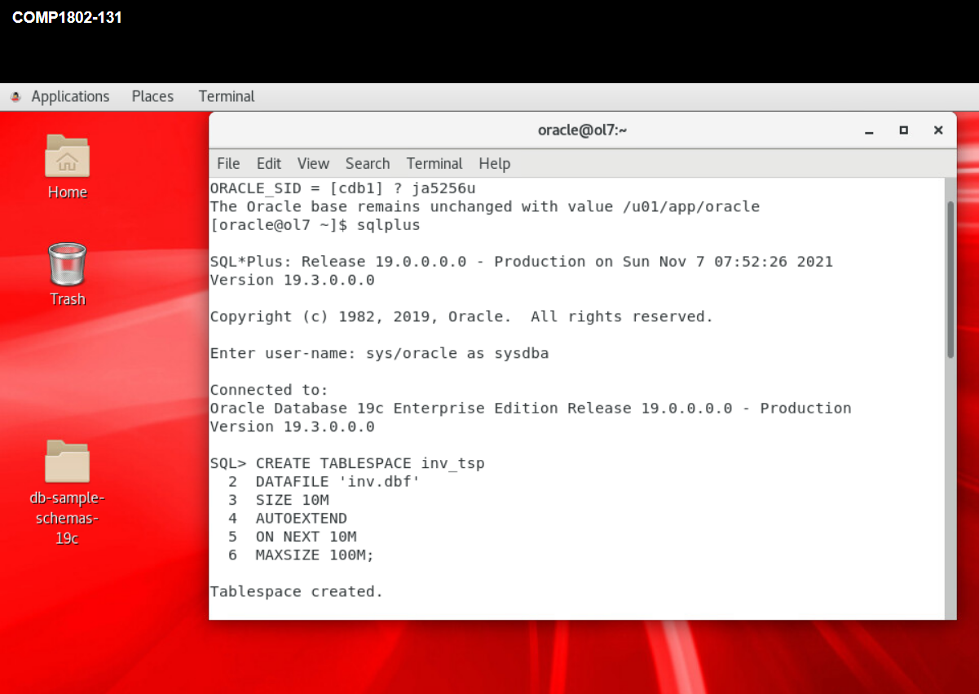

**Figure 1.1: Create the inv_tsp tablespace**

* **Query for the second tablespace**

CREATE TABLESPACE dw_tsp

DATAFILE ‘dw_tsp.dbf’

SIZE 120M AUTOEXTEND

ON NEXT 120M

MAXSIZE 300M;

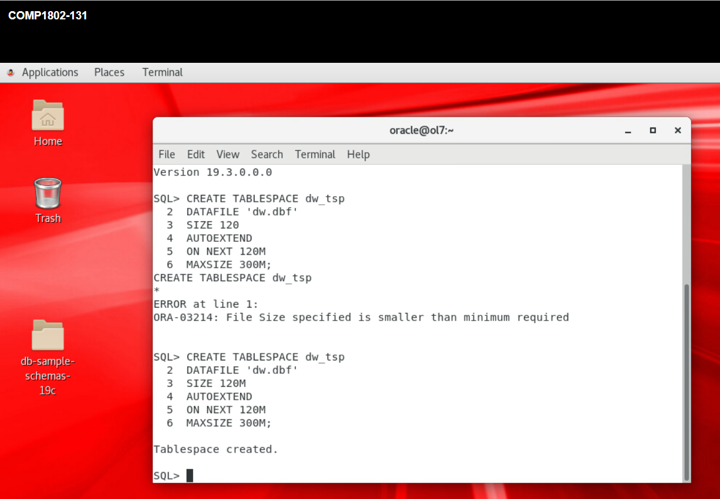

**Figure 1.2: Create the dw_tsp tablespace**

* Every tablepace should have its datafile, hence the reason I added accompanying datafile to each tablespace created. This allows us to label and identify the physical structure of our tablespaces easily. The inv_tsp tablespace is for transactional purpose, and it will be queried from time to time. We allocated as small as 10M to it because it won’t store as much information as dw_tsp. I made additional 10M available for it in case the first 10M earlier allotted is exhausted. The maximum size it should have is 100M.
* The dw_tsp is for warehousing application. It will store large data, hence the allocation of 120M. I also give it additional 120M in the event that the first is exhausted, and the maximum size it can have is 300M.
* The benefit of allocating extra memory is to ensure we don’t have difficult time or the need to start altering the tablespaces in the future.
* The drawback is that if we don’t exhaust the memory, then it means we are simply wasting memory size that could be used elsewhere.

**Creating the profiles to use for the users**

* **Profile for prof_cus_serv_dep1**

CREATE PROFILE prof_cus_serv_dep1

LIMIT PASSWORD_LIFE_TIME 180

FAILED_LOGIN_ATTEMPTS 3

IDLE_TIME 15

PASSWORD_LOCK_TIME 30/24 -- Database SQL reference – Oracle

PASSWORD_VERIFY_FUNCTION DEFAULT; -- Database SQL reference – Oracle

* **Profile for prof_cus_serv_dep2**

CREATE PROFILE prof_cus_serv_dep2

LIMIT PASSWORD_LIFE_TIME 180

FAILED_LOGIN_ATTEMPTS 3

IDLE_TIME 15

PASSWORD_LOCK_TIME 30/24 -- Database SQL reference – Oracle

PASSWORD_VERIFY_FUNCTION DEFAULT; -- Database SQL reference – Oracle

* **Profile for prof_inv_dep**

CREATE PROFILE prof_inv_dep

LIMIT PASSWORD_LIFE_TIMES 180

FAILED_LOGIN_ATTEMPTS 3

IDLE_TIME 15

PASSWORD_LOCK_TIME 30/24 -- Database SQL reference – Oracle

PASSWORD_VERIFY_FUNCTION DEFAULT; -- Database SQL reference – Oracle

* I created this profile as a precursor for the creation of users who can access the database. Several characteristics we want the users to have are stored in the profiles created using the commands written above.
* I could have used a single profile for the three users, since the arguments of their profiles are the same. However, there may be a need to alter the profile of an individual user and not for all of them, in the future, hence, the need to create the profiles separately.
* Serious measures and precautions must be put in place to ensure the security of our database. Some of this include locking out a user if they guess their password incorrectly 3 consecutive times; requiring them to change their password every 6 months. We could have given them grace period by passing the PASSWORD_GRACE_TIME argument, i.e., how long they will be warned to change their password after the expiration of the password life time. But it simply doesn’t meet our need in this case. We need them to change their password immediately after the password life time expires.
* I may have opted for the default parameters in Oracle for the profiles, but they do not meet our specific need in this case.
* I could have made the PASSWORD_LOCK_TIME 1 day which is the default, but using 30 hours, an equivalent of allow the users enough time to remember their passwords in the event that they fail to enter it correctly after 3 attempts.
* Password protection is the most common way to protect data in a computer system (Ruel, & Wessler, 2021). I ensured a user cannot have failed login attempt exceeding 3 times and they have got to wait 30 hours before they could login again. Also, user’s password is no shorter than 8 characters.
* A benefit of setting password lock time is that we will prevent our database from being bombarded with multiple password guesses.
* Stronger passwords guarantee security more than weak passwords, hence the need to make the password a minimum of 8 characters.
* A drawback is that having to remember a complex password is sometimes not very inconvenient. This is a drawback of placing strict security rule on a user profile.

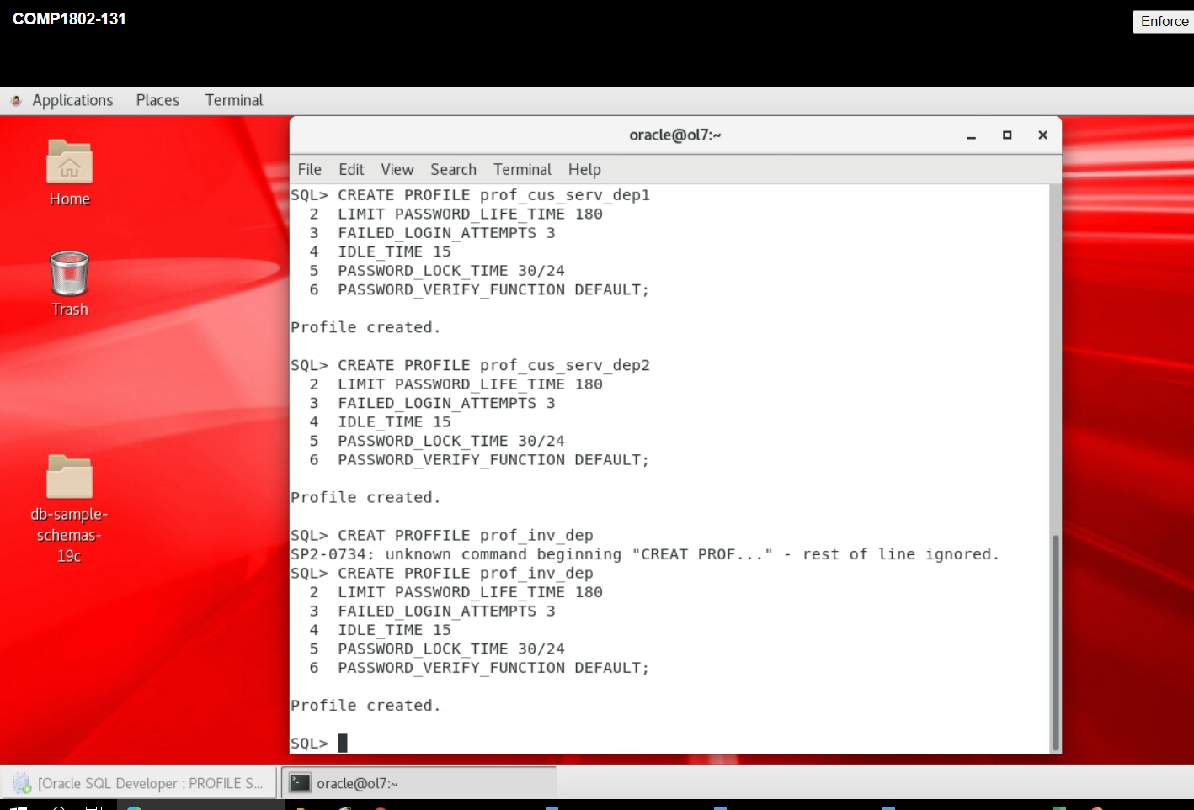

**Figure 1.3: Create profile for users**

**Creating the users**

* **Creating the first user in Customer Service department**

CREATE USER ARSENAL

IDENTIFIED BY Emirate02

DEFAULT TABLESPACE inv_tsp

TEMPORARY TABLESPACE temp

PASSWORD EXPIRE

PROFILE prof_cus_serv_dep1;

* **Creating the second user in Customer Service department**

CREATE USER CHELSEA

IDENTIFIED BY STANFORD03

DEFAULT TABLESPACE temp

PASSWORD EXPIRE

PROFILE prof_serv_dep2;

* **Creating the user in Inventory department**

CREATE USER LIVERPOOL

IDENTIFIED BY ANFIELD03

DEFAULT TABLESPACE inv_tsp

TEMPORARY TABLESPACE temp

PASSWORD EXPIRE

PROFILE prof_inv_dep;

* I created the user by giving them names and then assigning secure passwords that allow them login when necessary. A schema is created by default each time a user is created. I passed default tablespaces earlier created, and temporary tablespace temp present in the Oracle database by default to the users. I started with the CREATE USER command, pass the username; identify them by suitable and secure password, pass the profile specific to each user and mandate them to change their password the first time they login.
* The rationale behind this is to prevent a situation in which the passwords are compromised before they begin to use it.
* Creating users give us control over who we authorise to access the database. The alternative could have been making the admin login details available to all users. But this is never advisable, as we may be in for a serious security quagmire. It is best to create the users and grant only the necessary privileges which is needed to interact with the database.
* A drawback is that if a user forgets their password, it may lead to unwarranted delay in the business of the day.

**Table 1.1 Users and their Assigned Password**

|  |  |  |
| --- | --- | --- |
| **User** | **Department** | **Password** |
| ARSENAL | Customer Service | Emirate02 |
| CHELSEA | Customer Service | STANFORD03 |
| LIVERPOOL | Inventory | ANFIELD03 |

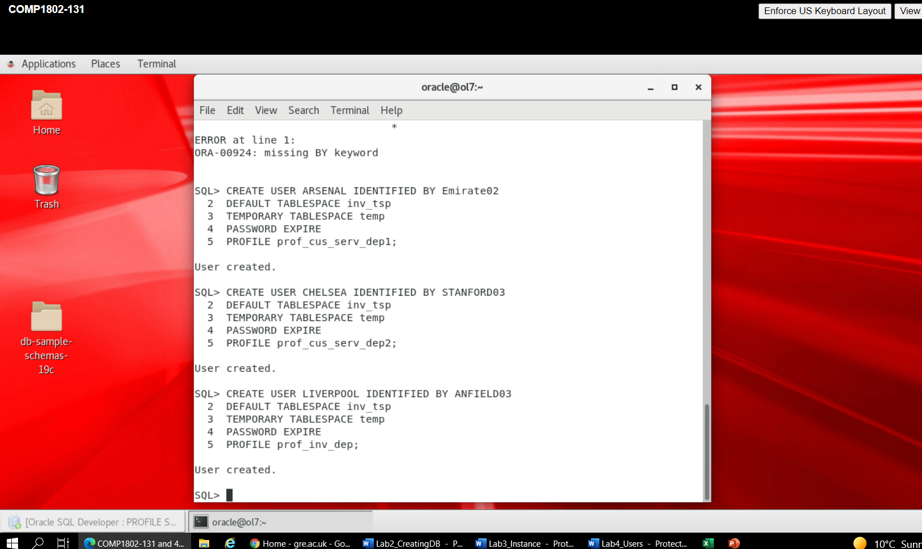

**Figure 1.4: Create users**

**Granting the users access to be able to login**

* **Grant access to cus_serv_dep1**

GRANT CREATE SESSION TO ARSENAL;

* **Grant access to cus_serv_dep1**

GRANT CREATE SESSION TO CHELSEA;

* **Grant access to cus_inv_dep**

GRANT CREATE SESSION TO LIVERPOOL;

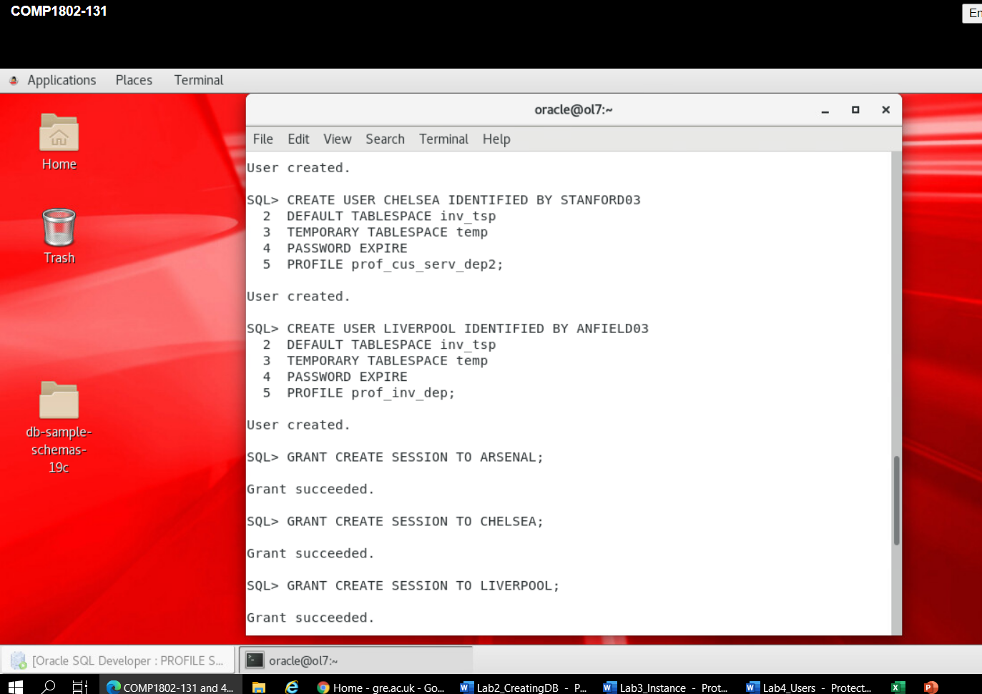

**Figure 1.5: Grant access to users to login**

**Granting read access to the two users for the Customer Service department on the oe schema**

* **Grant read access to ARSENAL**

GRANT SELECT ON oe.product_information TO ARSENAL;

GRANT SELECT ON oe.product_description TO ARSENAL;

GRANT SELECT ON oe.orders TO ARSENAL;

GRANT SELECT ON oe.order_items TO ARSENAL;

GRANT SELECT ON oe.customers TO ARSENAL;

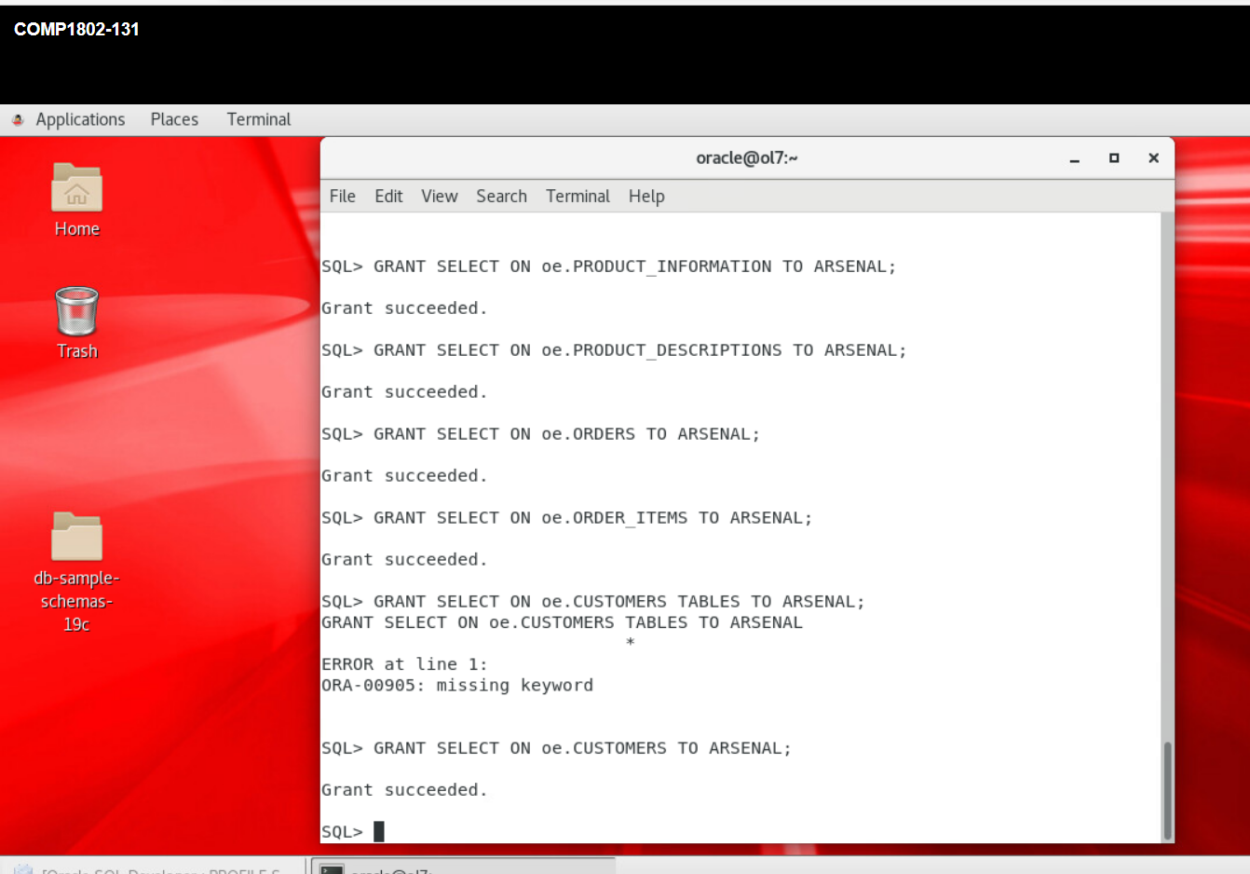

**Figure 1.6:** **Grant read access to ARSENAL on oe.product_information, oe.product_description, oe.orders, oe.order_items and oe.customers**

* **Grant read access to CHELSEA**

GRANT SELECT ON oe.product_information TO CHELSEA;

GRANT SELECT ON oe.product_description TO CHELSEA;

GRANT SELECT ON oe.orders TO CHELSEA;

GRANT SELECT ON oe.order_items TO CHELSEA;

GRANT SELECT ON oe.customers TO CHELSEA;

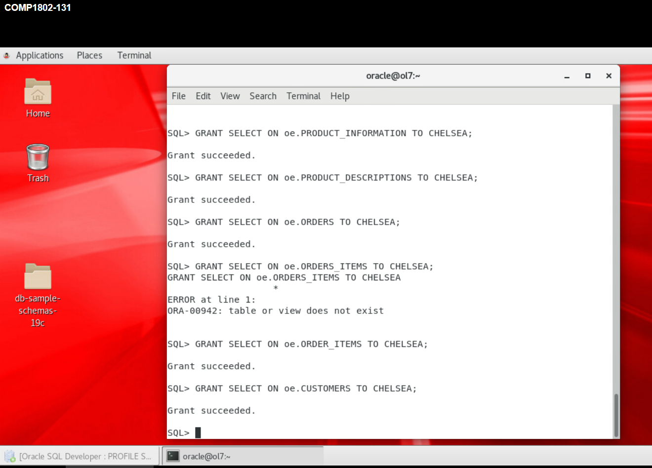

**Figure 1.7: Grant read access to CHELSEA on oe.product_information, oe.product_description, oe.orders, oe.order_items and oe.customers**

* Granting read/write access to the Customer Service department users could pose a security risk, so we limit the access to read only.
* To query information about all orders based on customer id, you need to use the WHERE clause, e.g., SELECT * FROM oe.orders WHERE customer_id = 2;
* **Simplifying the task of querying the database for Customer Service department users**
* To pull data from multiple tables in a single query, you need the JOIN keyword. There are four possible JOINs you can do in the database. They include RIGHT JOIN, LEFT JOIN, INNER JOIN and OUTER JOIN. To perform join on two or more tables, you must be sure that there is a column common to the tables considered. To perform INNER JOIN on CUSTOMERS table and ORDERS table, for instance, you can run the command:

SELECT CUSTOMERS.customer_id, CUSTOMERS.cust_first_name, CUSTOMERS.cust_last_name, ORDERS.order_id, ORDERS.order_date, ORDERS.order_status

FROM

CUSTOMERS

LEFT JOIN ORDERS USING(customer_id)

WHERE CUSTOMERS.cust_id IN (1, 3, 4, 5) ;

The query above will allow you get information such as their id, first name, last name, and their order id, order date and their order status. The customers with ids of 1, 3, 4 and 5 will be affected in this query.

**Granting read/write access to the user for the Inventory department on the oe schema**

GRANT SELECT, INSERT, UPDATE ON oe.inventories, oe.warehouses to LIVERPOOL;

* While granting the user for the Inventory department read/write access on the oe schema’s objects, I could have granted them the DELETE privilege, but this is not advisable because it can cause security loopholes, so I didn’t grant him this privilege.

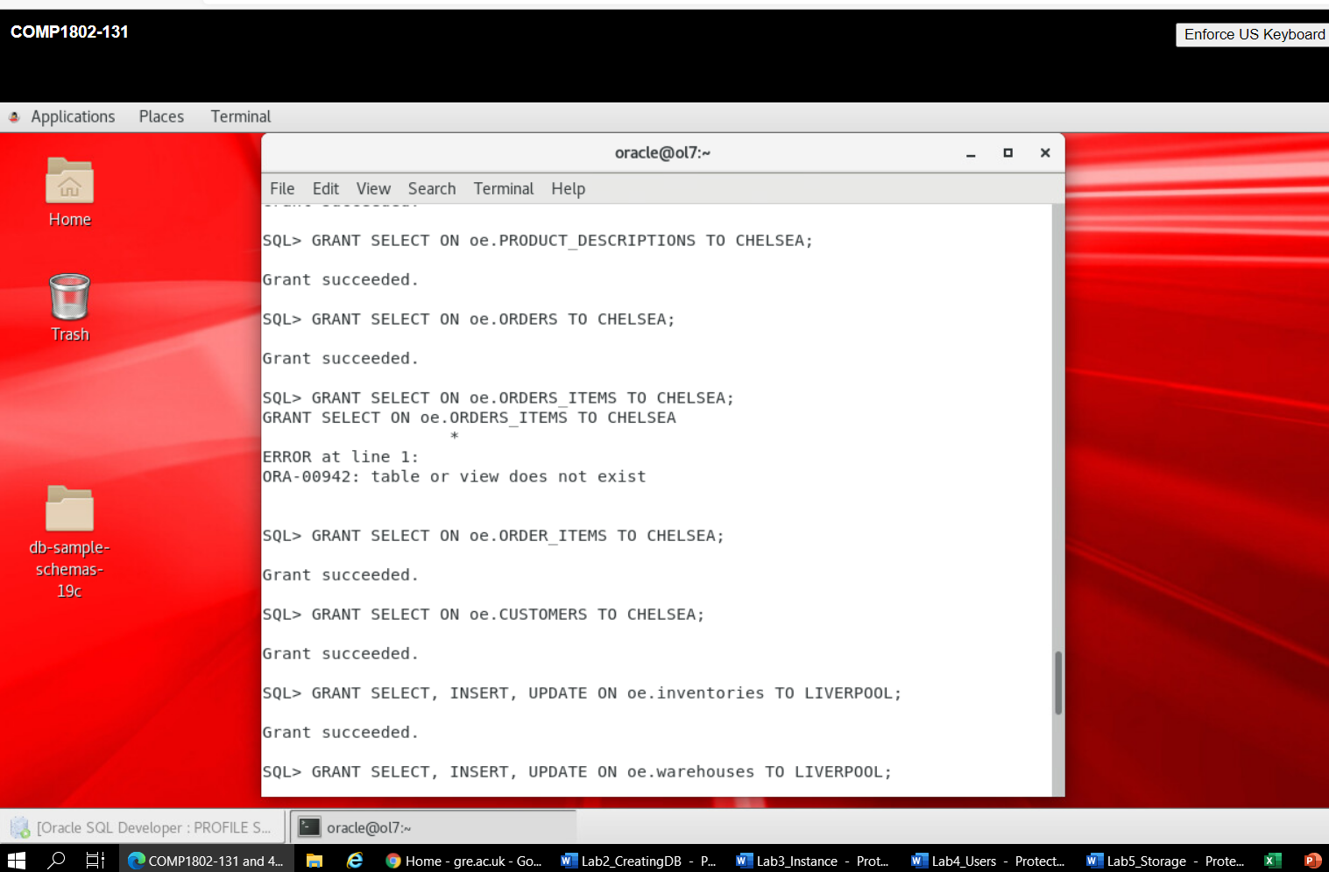

**Figure 1.8: Grant read/write access to LIVERPOOL on oe.inventories and oe.warehouses**

**Granting read access to the user for the Inventory department on the oe schema**

GRANT SELECT ON oe.orders, oe.order_items, oe.customers TO LIVERPOOL;

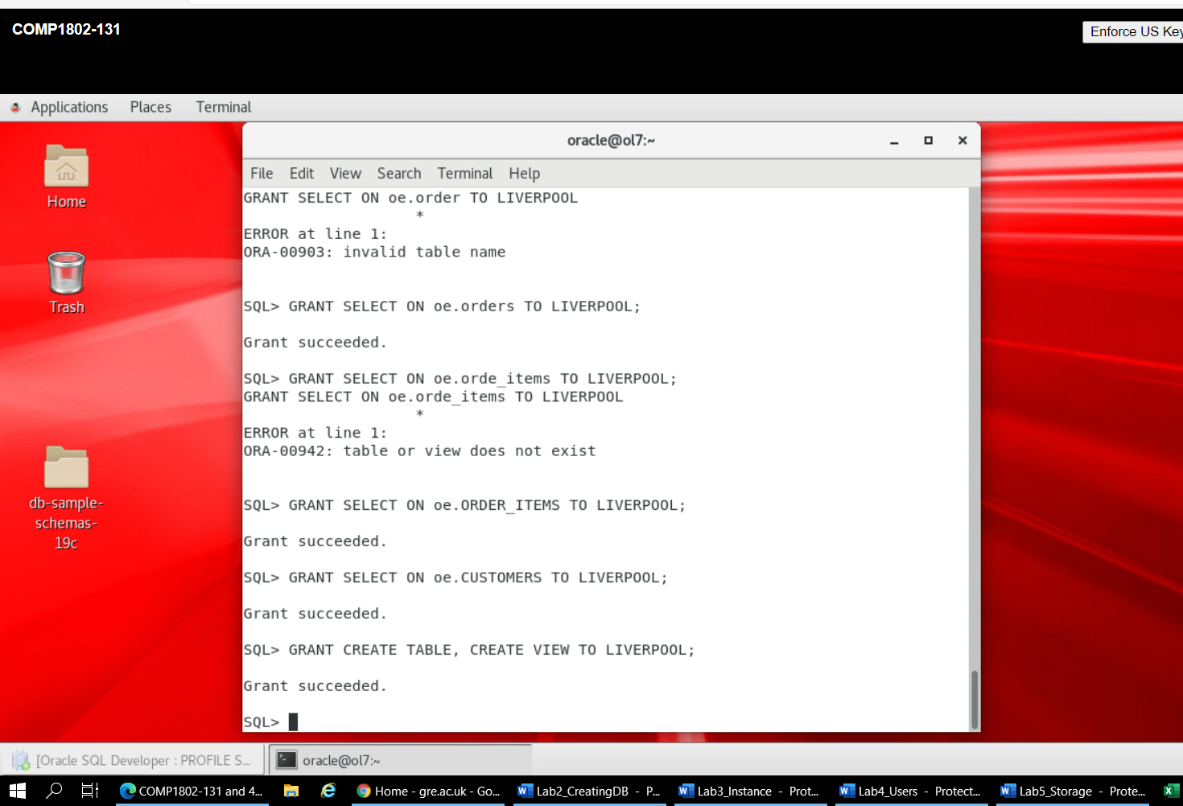

**Figure 1.9: Grant read access to LIVERPOOL on oe.orders, oe.order_items, and oe.customers**

**Allowing the user for the Inventory department to be able to create tables and views**

GRANT CREATE TABLE, CREATE VIEW TO LIVERPOOL;



**Figure 1.10: Grant create table and create view privileges to LIVERPOOL**

* To grant the necessary privileges to the users, the GRANT command is used. The Customer Service department users only have read access so we granted them the SELECT privilege. Meanwhile, the Inventory department user have read/write access on some tables and read access on few others. We granted them the privileges accordingly.
* The Inventory department user was authorised to create tables and vies, so we granted them the privileges using GRANT CREATE TABLE and CREATE VIEWS respectively.
* For the Inventory department user to be able to create a table in his schema, we must grant them the privilege to be able to login. This has been granted earlier. The user will be required to change the password the first time they login. This is because of the PASSWORD EXPIRE component of the CREATE USER command. An alternative would have been to login as the admin, and thereafter alter the session to the Inventory department user’s schema as follows:

ALTER SESSION SET CURRENT_SCHEMA = LIVERPOOL;

Now to create the table:

CREATE TABLE inv_categories(

cat_id NUMBER NOT NULL,

sub_cat_id NUMBER NOT NULL,

cat_name VARCHAR2(25),

sub_ cat_name VARCHAR2(25),

cat_description VARCHAR2(50),

available CHAR(1),

CONSTRAINT pk_inv_categories PRIMARY KEY (cat_id, sub_cat_id),

CONSTRAINT chk_avlbl CHECK(available IN (‘Y’,’N’)) -- From Stackoverflow

)

TABLESPACE inv_tsp;

* An alternative to CREATE TABLE is CREATE ANY TABLE. Granting the latter to a user allows them to create table in the SYS and SYSTEM schema, as well as any other table. This can lead to serious security risk, hence, I opted for CREATE TABLE. It is important that we avoid security violation.
* To create the table: inv_categories, we use the CREATE TABLE command. The necessary columns were created in the table, and passed constraints relevant to them. The table has a composite primary key, utilising both the cat_id and sub_cat_id, meaning that but must be NOT NULL to be used as the primary key. Inventory is either available or not available. If it is available, it will be ‘Y’ which means yes, and if it is not available, it will be ‘N’ which means no. The primary key constraint is given the user-defined name ‘pk_inv_categories’ and the check constraint is given the user-defined name ‘chk_avlbl’. Lastly, the table is stored in the inv_tsp tablespace.

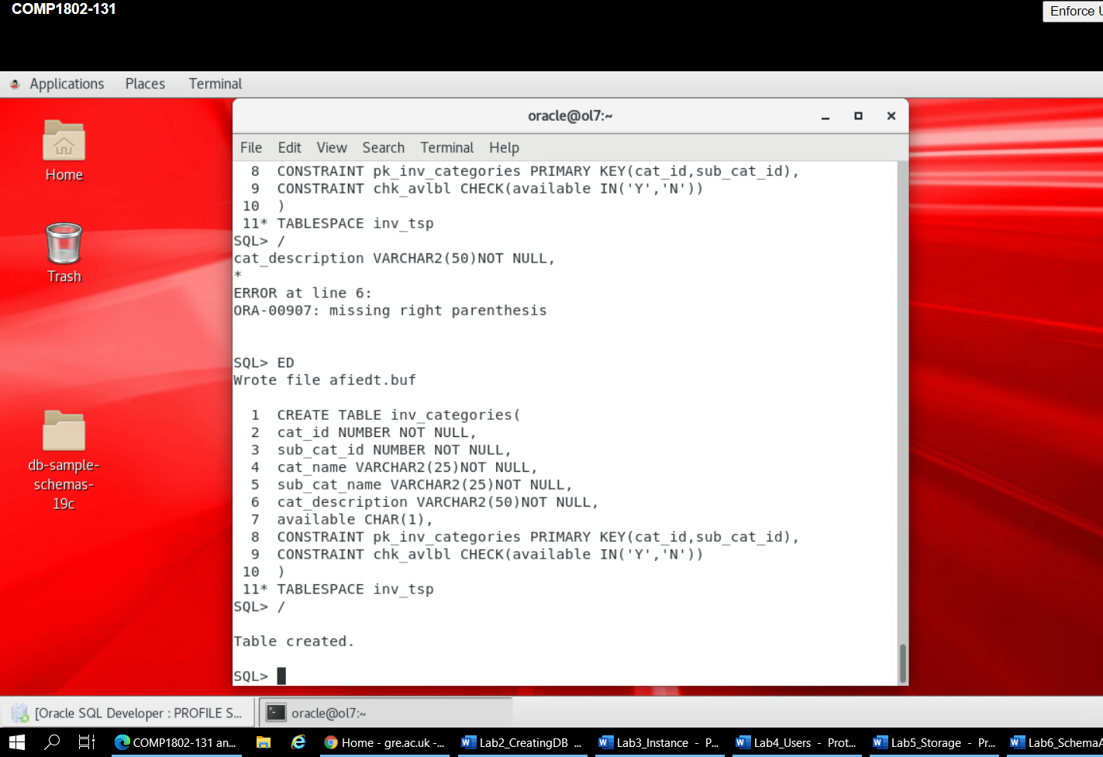

**Figure 1.11: Liverpool creates the inv_categories table**

* **Enabling the sh user to create a report**
* To enable the sh user to create a report about all products sold for a particular customer, based on the provided customer id, they must be granted the privilege to be able to login into the database, and also have at least read access to the table. The privileges will be created as follows:

GRANT CREATE SESSION TO sh;

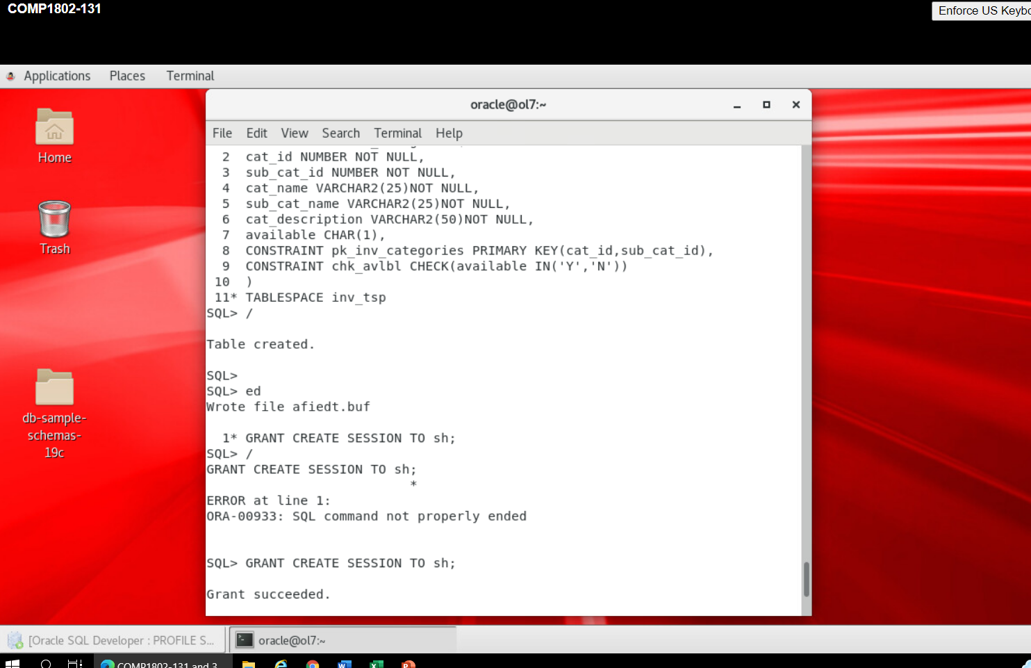

**Figure 1.12: Grant create session to sh**

GRANT SELECT ON sh.sales to sh;

GRANT SELECT ON sh.products to sh;

GRANT SELECT ON sh.customers TO sh;

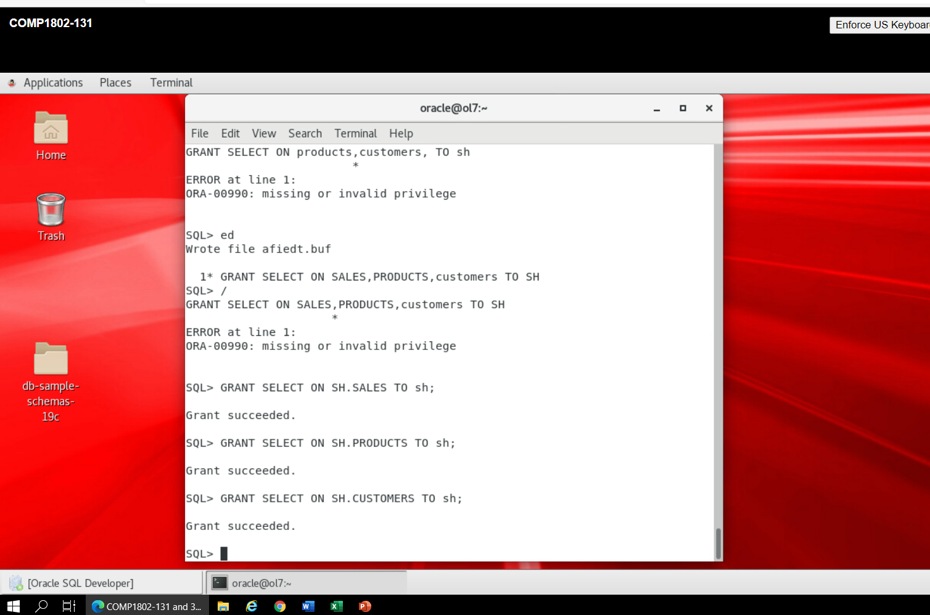

**Figure 1.13: Grant select table to sh**

ALTER SESSION SET CURRENT_SCHEMA = sh;

Then the report is made as follows:

SELECT sales.quantity_sold, sales.amount_sold, products.prod_name, customers.cust_first_name, cust_last_name

FROM

Sales

INNER JOIN customers

ON sales.cust_id = customers.cust_id

INNER JOIN products

ON sale.prod_id = products.prod_id

WHERE customers.cust_id =3;

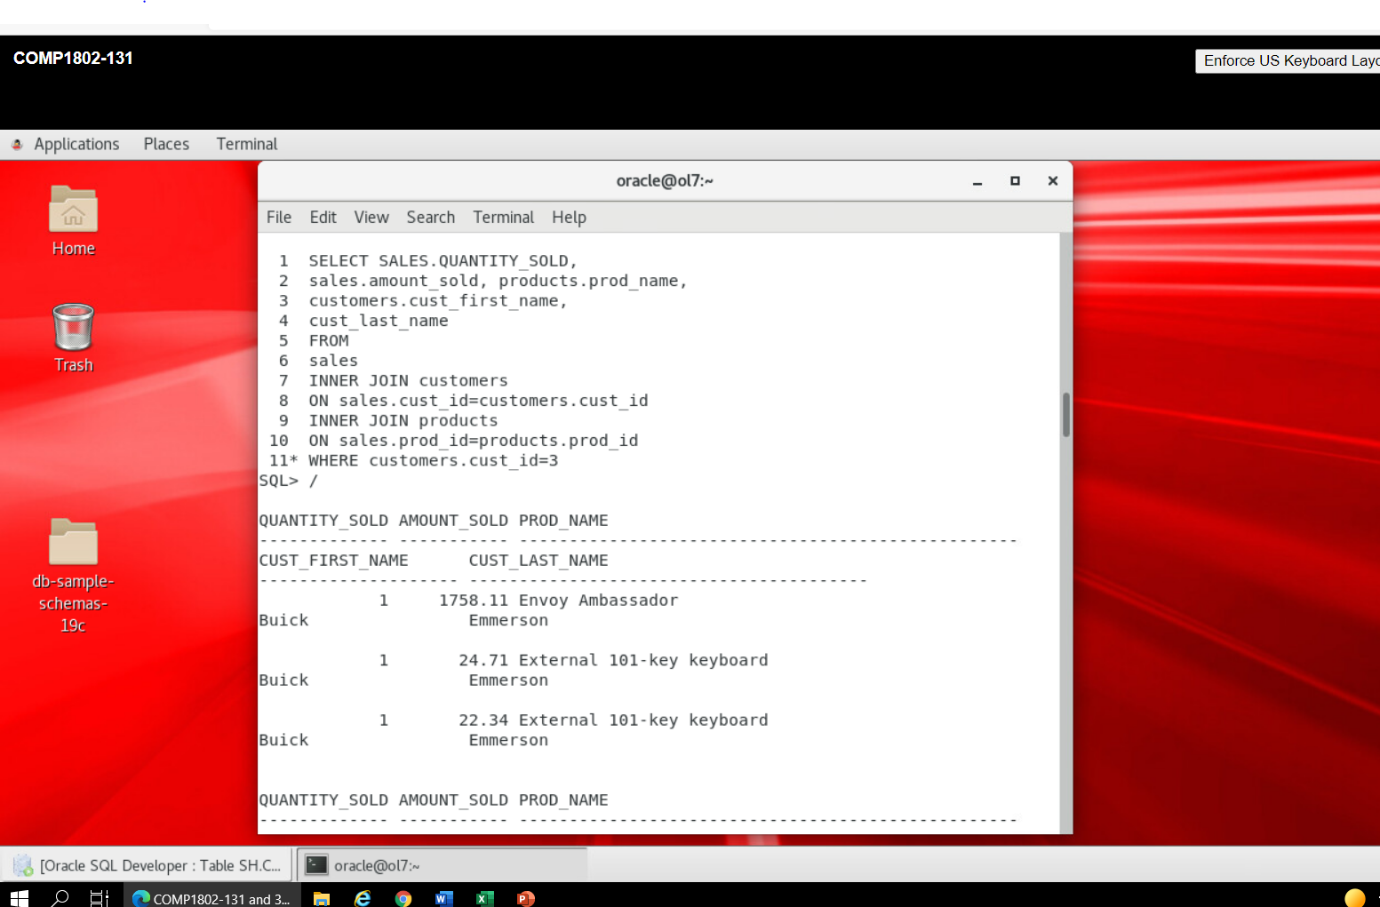

**Figure 1.14: Create a report based on a customer id using JOIN keyword**

* The rationale for using INNER JOIN is to ensure we return information relating to the customer in all the tables concerned. The alternative include LEFT JOIN and RIGHT JOIN. LEFT JOIN will return all the values from the left table irrespective of whether there are matching rows from the right table. Any row in the right table where there is no data will be left blank.

As an alternative to using ‘sales.cust_id = customers.cust_id’, the user could have used ‘USING(cust_id)’. Also, as an altenative to using sale.prod_id = products.prod_id, the user could have used ‘USING(prod_id)’. The drawback here however, is that for any two tables, the common column must have the same name in both of the tables, as it is the case in this situation, but this is not always the case. In a nutshell, the USING keyword is applicable when both tables to be joined have a common column (primary and foreign key) with exactly the same name.

* All the queries are run in the Oracle command line tool, SQL*PLUS. An alternative to the command line tool is SQL Developer which offers a GUI for users to run queries. I chose SQL*PLUS because it is more powerful than the SQL Developer. A major drawback, however is that once one runs into errors more easily; one has to run the queries afresh. It doesn’t provide the opportunity to edit your queries and re-run.
* **Recovering An Accidentally Dropped Schema**

With flashback method, it is possible to recover an accidentally dropped schema. I will ensure I flashback the database to past, when the schema was available in the database. An accidental way I could have dropped the schema is using: DROP USER *username* CASCADE;

As a first step, I have to ensure flashback and archivelog mode is enabled. Also, all the flashback logs and archives must be available from the time the user is dropped. To check: SELECT FLASHBACK_ON FROM V$database;

If the output is NO, then, I will alter the database as follows:

ALTER DATABASE ARCHIVELOG;

ALTER DATABASE FLASHBACK ON;

I will confirm again to see if it is now on:

SELECT FLASHBACK_ON, LOG_MODE FROM V$database;

Now, I will flashback the database to past, when the user was available as follows;

SET TIME ON;

SHUTDOWN IMMEDIATE

STARTUP MOUNT

FLASHBACK DATABASE TO TIMESTAMP, to_date(‘the current date’, ‘DD-MM-YYYY HH24:MI;SS’);

I will open the database in read only mode:

ALTER DATABASE OPEN READ ONLY;

Now, I will confirm the tables are restored in the schema:

SELECT table_name FROM dba-tables WHERE owner= ‘user_name’

I will export the backup of the schema *username;*

HOST exp owner = *username* file =*username.*dmp

I will restore the database to the current stage:

SHUTDOWN IMMEDIATE

STARTUP MOUNT

RECOVER DATABASE OPEN;

ALTER DATABASE OPEN;

Now, I will create an empty user and import the dump:

CREATE USER *username*

IDENTIFIED BY *password*

GRANT CONNECT, RESOURCE TO *username;*

HOST imp file = *username.*dmp FROM USER = *username* TO USER = *username*

* **ORA-1555: Snapshot too old errors: Cause and Solution**

“ORA-1555: Snapshot too old” errors occurs as a result of Oracle read inconsistency mechanism, i.e., Oracle cannot access the original copy of the data from when the query began and it at the same time cannot undo changes as they are made. If there are lots of updates, long running SQL and too small UNDO, the ORA-01555 error will appear (Burleson, 2015).

If for example, one of the users begin to query the database at 3:15 pm, yet another person is making changes to the data from his/her own end on another computer, then an “ORA-1555: Snapshot too old” errors may occur.

The reason is because the data is no longer available for the first user as it was before the changes were made.

To solve this issue, I will:

* Ensure users don’t run discrete queries and sensitive queries simultaneously unless the data is mutually exclusive.
* Schedule queries during the off-peak hours to ensure consistent read blocks do not necessarily nee rollback changes.
* Use a large database block size to maximise rollback segment for transaction table slots.
* Increase the size of the UNDO tablespace, and set the UNDO tablespace in GUARANTEE mode.
* Ensure users commit less often in tasks that will run at the same time as the sensitive query, particularly in PL/SQL procedures to reduce transaction slot reuse.
* Reschedule long-running queries when the system has less DML load.
* If necessary, add extra rollback segments (undo logs) to make more transaction slots available
* **Hot Backup versus Cold Backup**

Hot backup is done when the database is open. It is used when a full backup is needed and the service level does not allow system downtime. The system is active during hot backup. A hot back up is completed successfully when the database is in archivelog mode, which implies the database is saving any change taking place in the database to archivelog tiles. Cold backup on the other hand is a backup taken when the database is closed. It is done when the service level allows for the required system downtime. The database has to be in a shutdown state.

* **Benefits of Hot Backup**
* users can modify the database during the backup
* Log files of changes made during the backup are saved.
* It helps to minimise downtime on a day-to-day basis
* During hot backup, data is still accessible to users.
* The database need not be closed during the backup.
* **Benefits of Cold Backup**
* There is no recovery required during a restore.
* Archivelog mode is not required.
* Restoring is much less complex.
* There is less risk of errors occurring during the backup
* It is less prone to hacking attempts.
* **How Different Database Failure Can Impact A Business**

Database failure can be a nightmare for a business, and it can come with huge financial costs. No matter how reliable the database system is, or how competent the database administrator of a company is, database failure is still very much possible (Stronghold Data, 2019). Database failure can be broadly classified into two:

* Downtime
* Loss of data

Downtime: Downtime is a period in which the database is not available for use as a result of system failure. During downtime, a business obviously cannot provide services to their customers and may lose huge amount in income. Downtime can frustrate customers and this is costly to the business. It can lead to losing valuable customers.

Loss of Data: here, there is loss of valuable information stored on the server. This situation can put a business in deep financial and legal problem. Loss of data may be accidental o deliberate. Deliberate in the sense that an unscrupulous person may delete important data from the database when no one is watching.

Database failure may lead to paralysis of information systems, which poses a great threat to enterprise operations and production safety (Zhang *et al*, 2018). Database failure can have a huge impact on the affected business in the following ways:

* The company’s reputation can be affected. Clients do not want to deal with businesses where the safety of their data cannot be guaranteed.
* The company can be embroiled in serious litigation.
* The company can be fined by the government for non-compliance with relevant guidelines on data management.
* The company can lose valuable clients
* It can lead to a huge financial loss.

According to Linktek, database downtime costs companies an average of $7,900 per minute and according to a survey carried out on 200 companies, more than $26.5 Billion in revenue is lost each year from system downtime (Harris, 2011).

Downtime costs can be minimised in the following ways:

* Have a backup plan for the data stored in the database.
* Have a sound disaster recovery plan in place.
* Schedule operations smartly
* Ensure only authorised staff have access to the company’s database.

Several cases of Oracle database failure in large organisations have been reported in the past. A case in point is DreamHost. In 2007, not fewer than 500 websites hosted by the company began to disappear from the web. This occur as a result of a bug in one of their routers. DreamHost managed to fix the issues and then thought everything was fine, only to find out that DNS records were being deleted by the said bug. The company was not able to successfully restore all the data lost. This led to loss of confidence among clients. DreamHost learnt their lessons (that they would have prevented the sad occurrence if they had backed up in a safe location) and apologized to all the customers affected. They have taken conscious efforts to improve their security and rebuild their reputation (Stronghold Data, 2019).

**References**

Burleson, D. (2015). Oracle concepts – backup and recovery concepts. <http://www.dba->

oracle.com/concepts/backup_recovery.htm

Burleson, D. (2015, November 8). How to enforce a minimum password length. <http://www.dba-oracle.com/t_password_length.htm>

Burleson, D. (2015, March 25). Recover dropped schema with flashback database.

http:www.dba-oracle.com/t_rman_158_recover_dropped_schema.htm

Database SQL reference (2017).

https://docs.oracle.com/database/121/SQLRF/statements_6012.htm#SQLRF01310

Harris, C. (2011, May 24). IT downtime costs $26.5 Billion in lost revenue).

https://www.informationweek.com/ cloud/it-downtime-costs-26-5-billion-in-lost-revenue

Linktek. (2017, January 24). The cost of network downtime. <https://linkktek.com/cost-of-network->

downtime/

Ruel, C. & Wessler, M. (2021). Basics of Password authentication. Dummies.

<https://www.dummies.com/programming/databases/basics-of-password-authentic-in-oracle-12c/>

Stackoverflow. (2015, May 3). How do you modify the default to accept Y or N not just Y in SQL. <https://stackoverflow.com/q/30009161>

Stronghold Data. (2019, January 17). 4 real-life examples of data loss.

https.//strongholddata.com/4-real-life-examples-of-data-loss/

Zhang, M., Chen, Z., Wang, H.; Zeng, Z., & Shan, X. December). Research on database failure

prediction based on deep learning model. *Top Conference Series Materials in Science and*

*Engineering, 452(3). https://doi.org/10.1088/1757-899X/452/3/032056*